TITLE: POSTER CREATION

USER NAME: 834AAAE551148BD8EF94A7CB717881E6

1.Open canva App

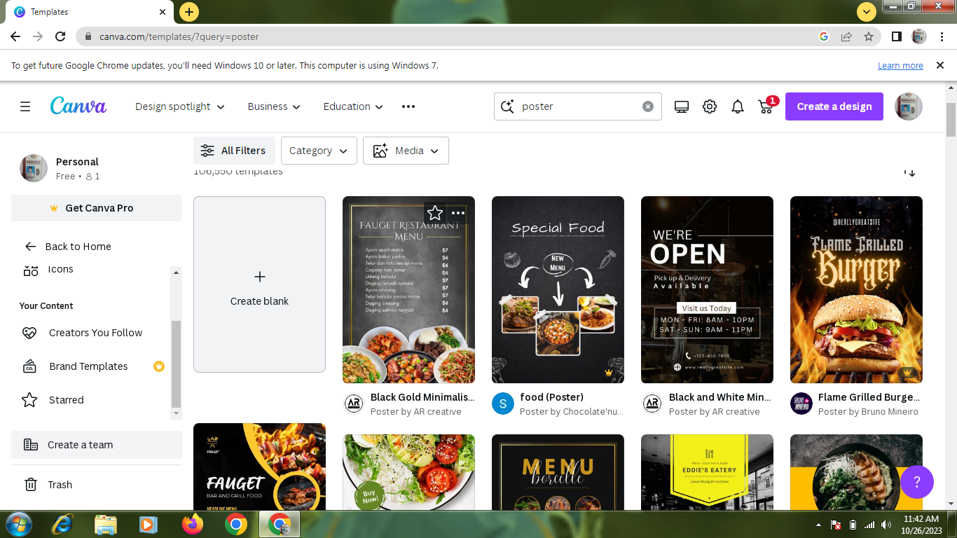

2. select a template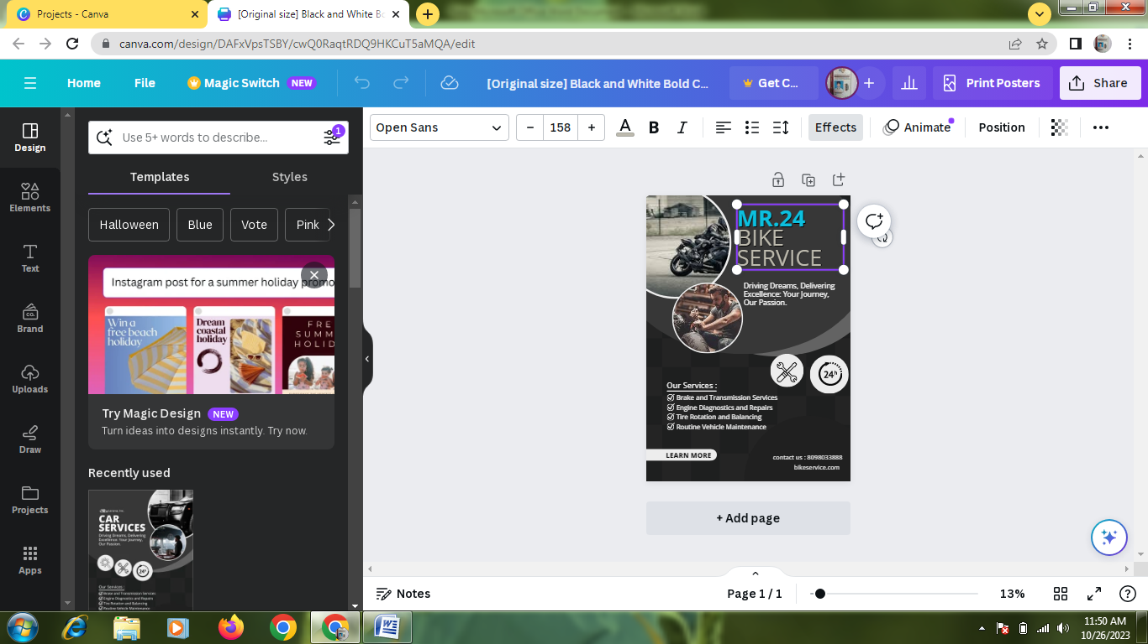

3.Edit a details



4.Upload a business related image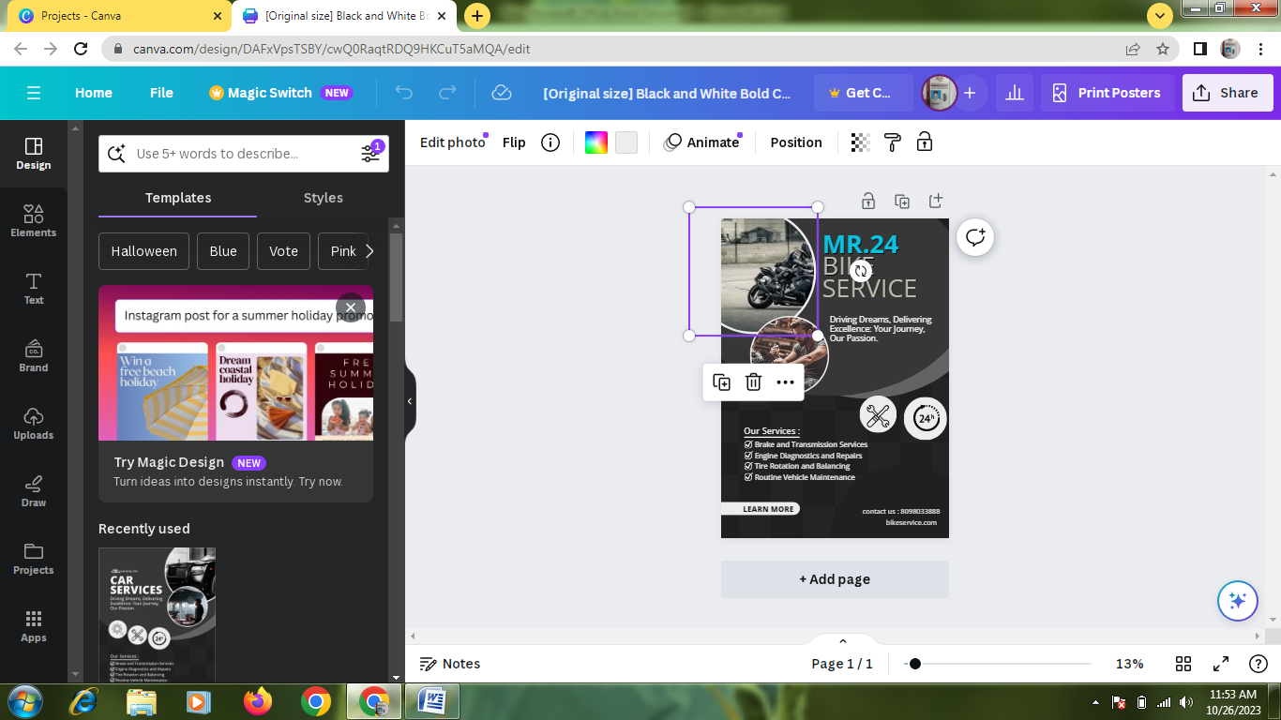

5.Pdf convert

